**Samuel Isken A50646167 STT 465 HW 6**

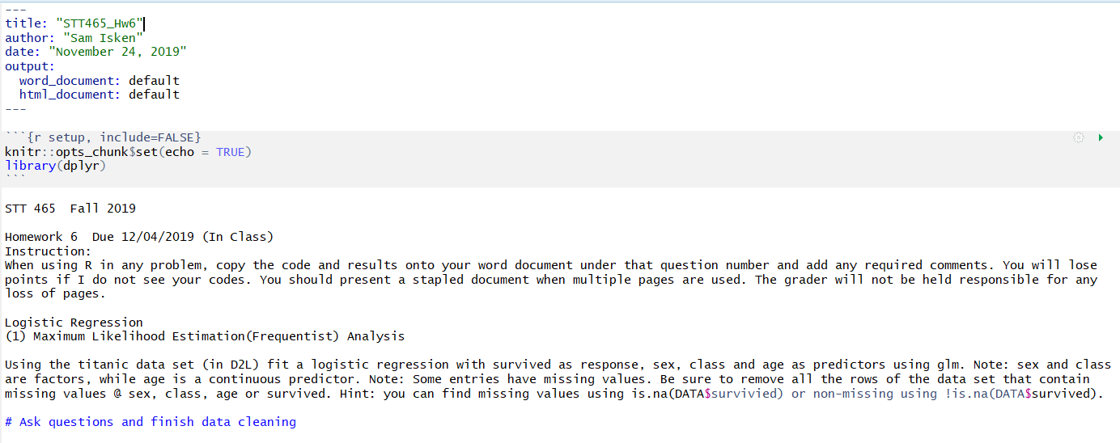

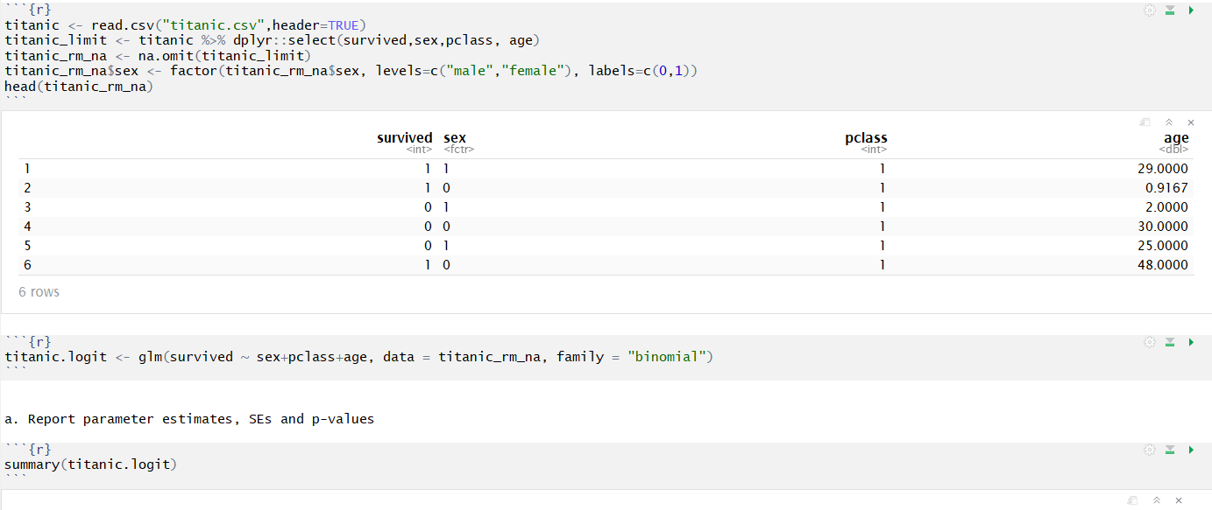

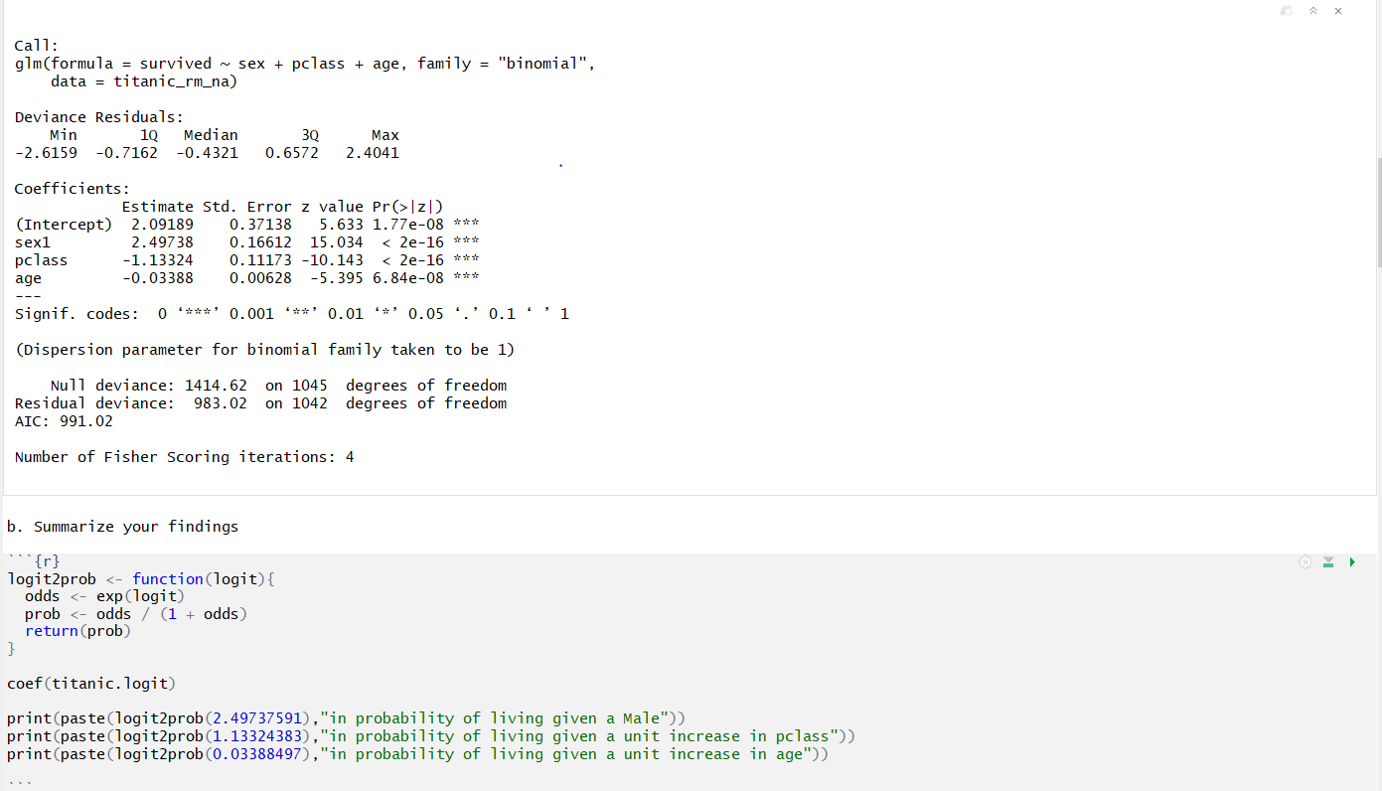

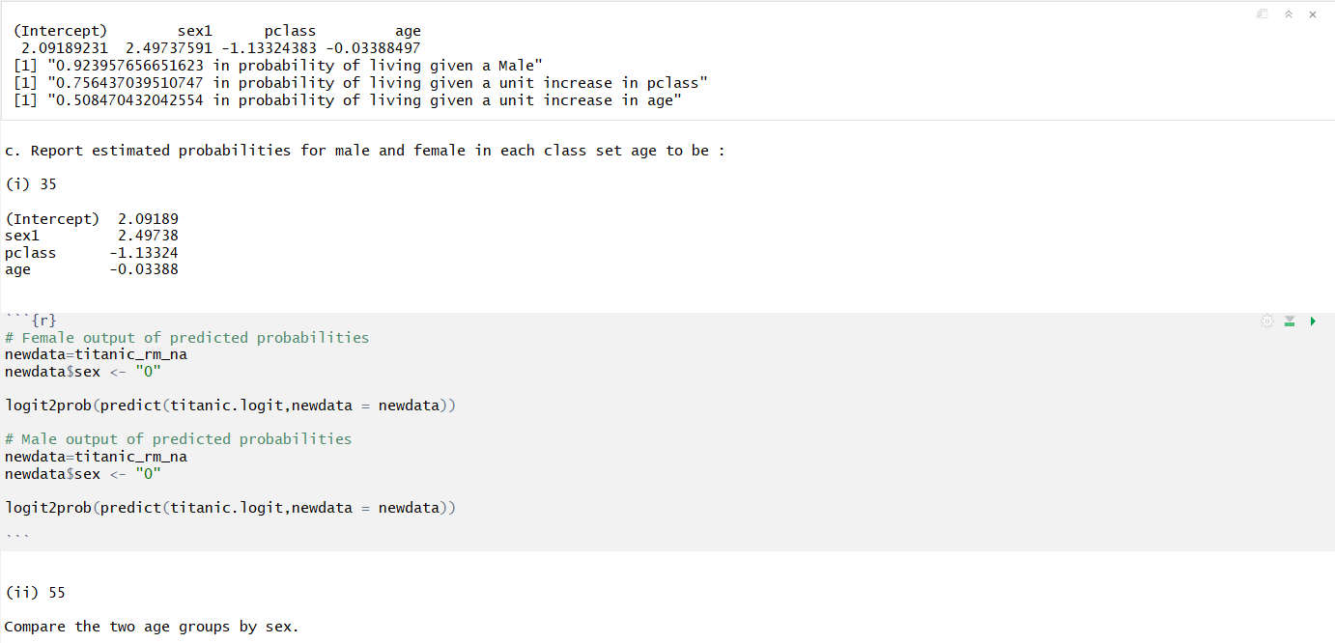

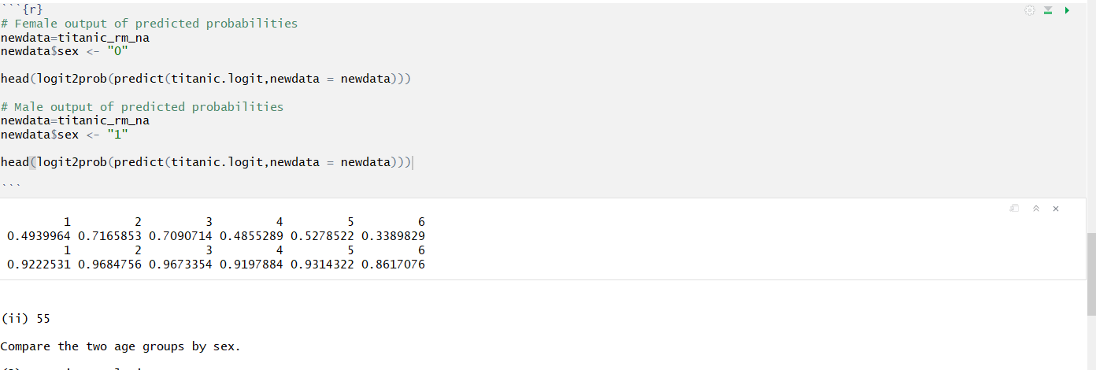

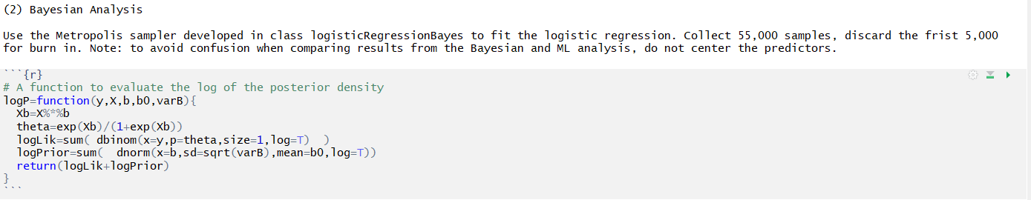

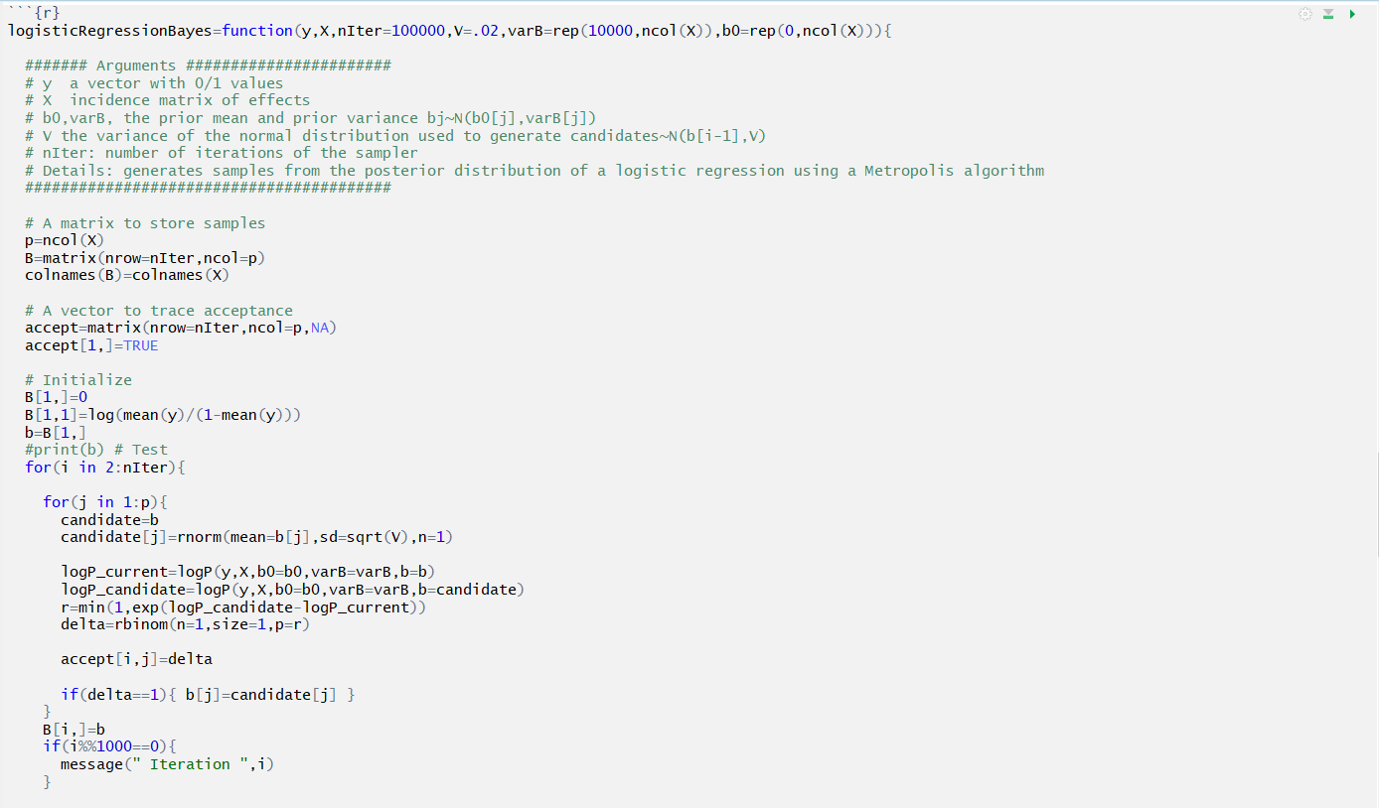

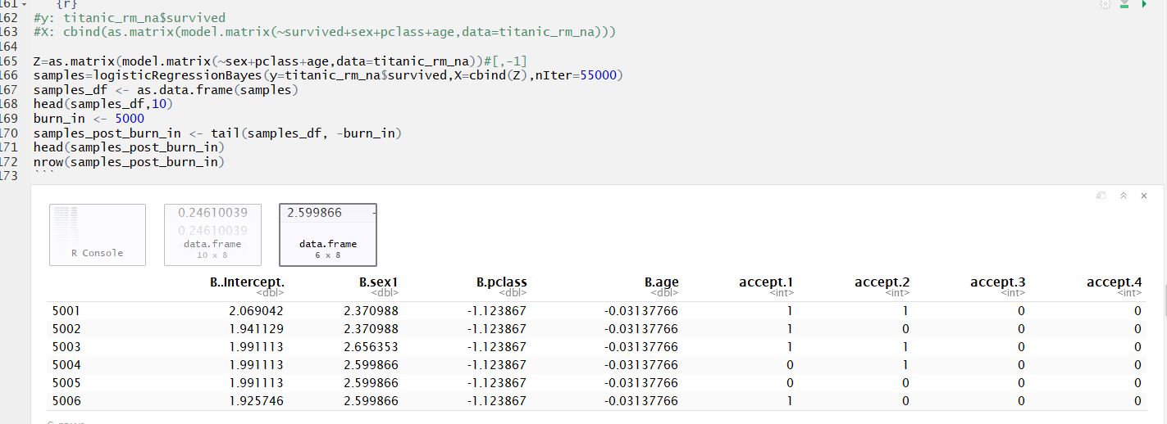

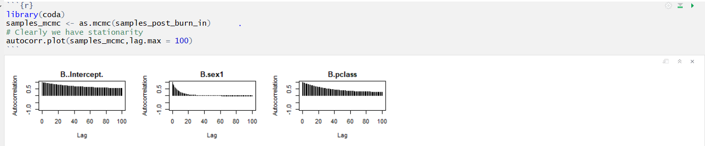

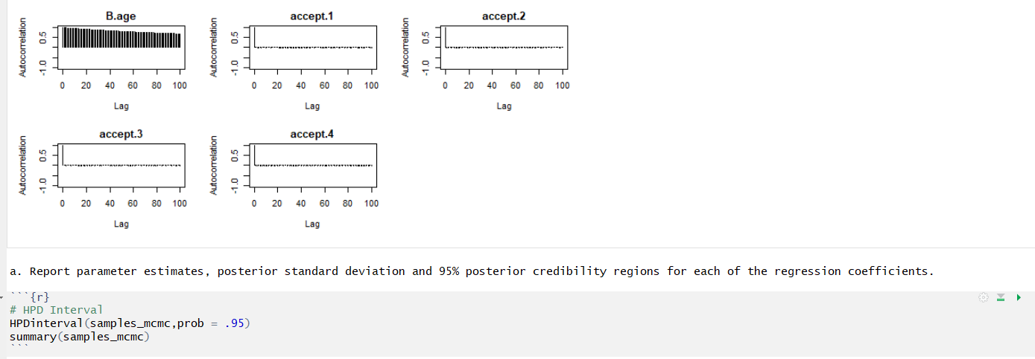

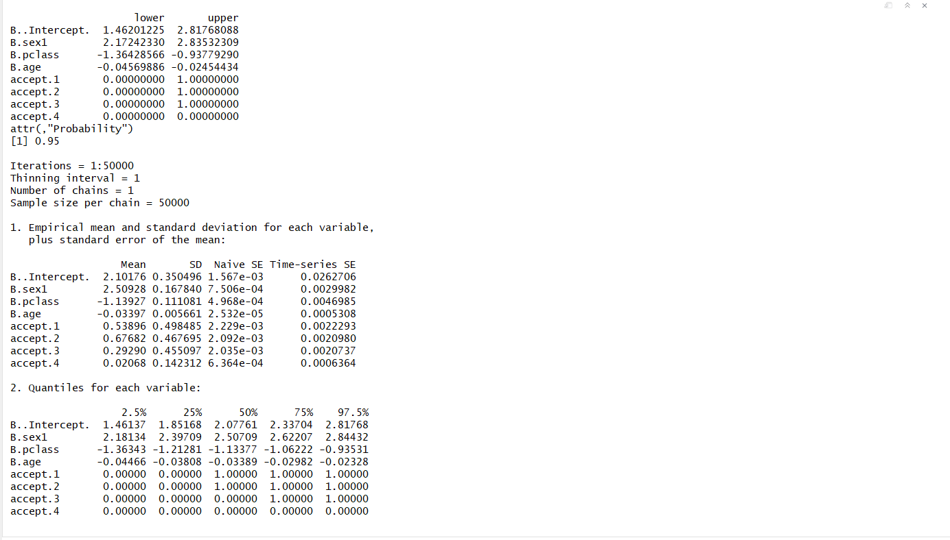



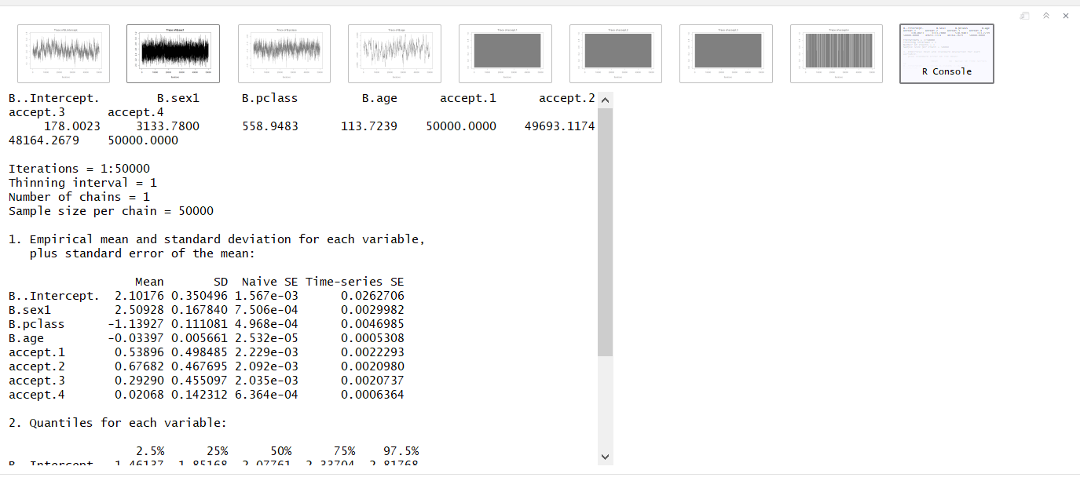

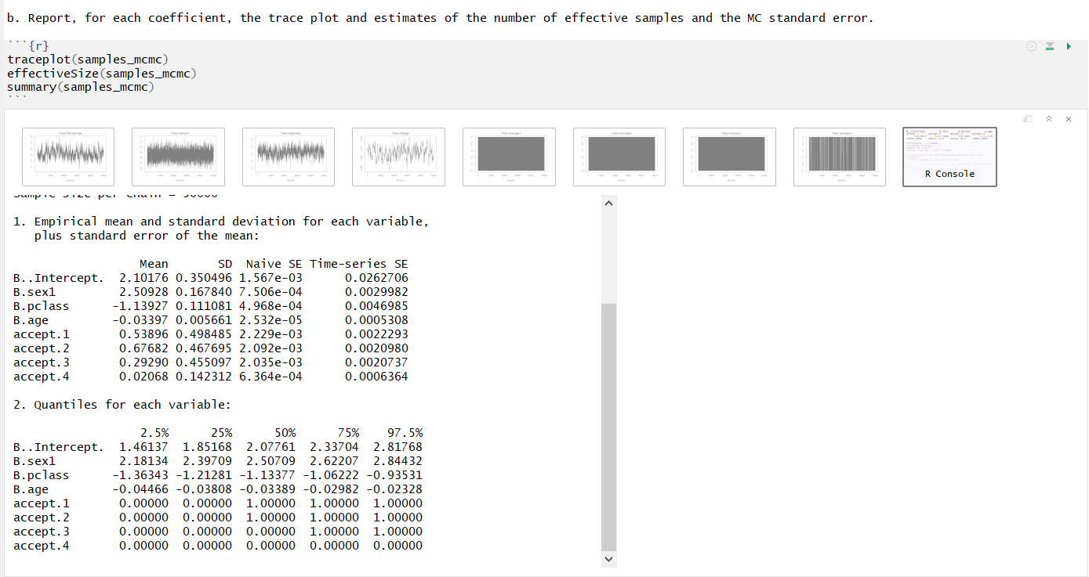

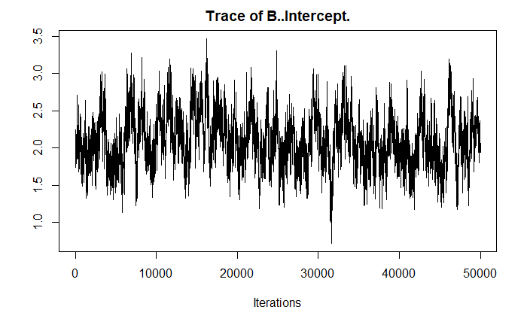

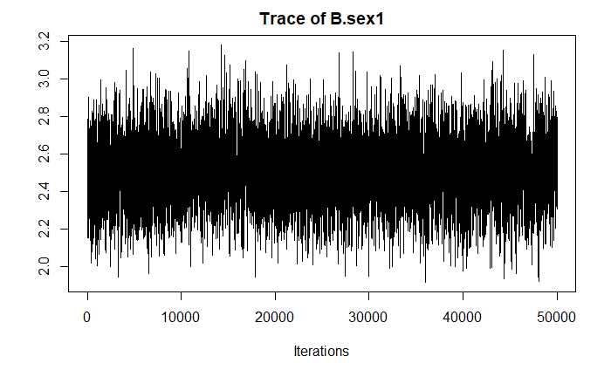

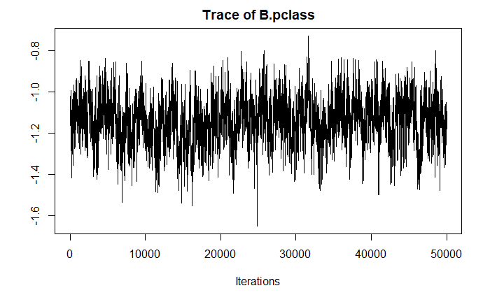

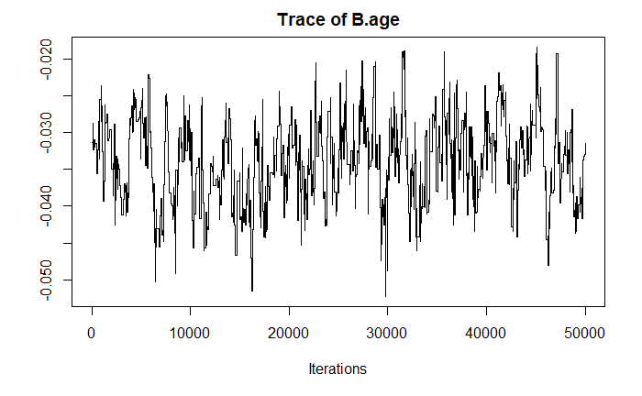

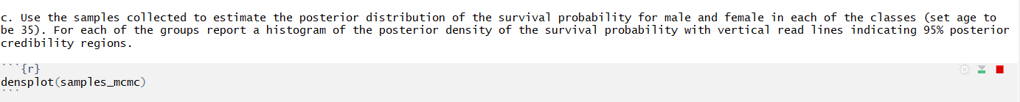

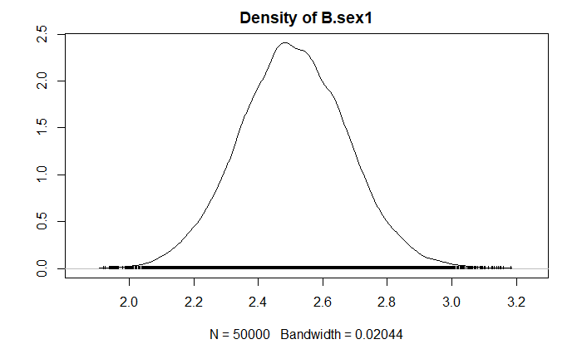

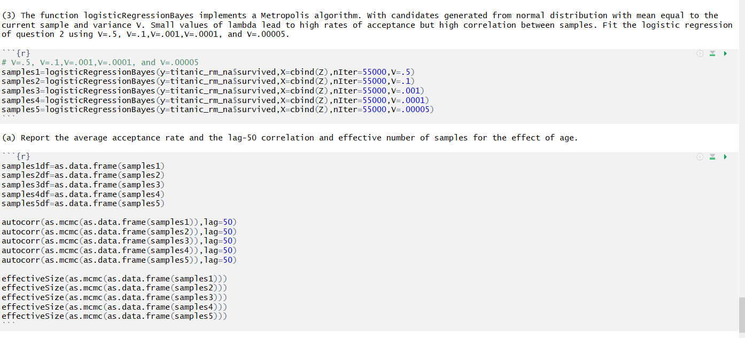

, , B..Intercept.

B..Intercept. B.sex1 B.pclass B.age accept.1 accept.2 accept.3 accept.4

Lag 50 0.8476358 0.09498812 -0.7200324 -0.7847123 0.008414117 -0.0008330996 -0.00151565 -0.008851691

, , B.sex1

B..Intercept. B.sex1 B.pclass B.age accept.1 accept.2 accept.3 accept.4

Lag 50 0.1029826 0.02072339 -0.1183632 -0.05616977 0.001355073 -0.0008874457 0.006781075 0.0003984492

, , B.pclass

B..Intercept. B.sex1 B.pclass B.age accept.1 accept.2 accept.3 accept.4

Lag 50 -0.7269724 -0.1098065 0.7497529 0.5022246 -0.009505413 0.003590571 -0.0002194745 0.004465966

, , B.age

B..Intercept. B.sex1 B.pclass B.age accept.1 accept.2 accept.3 accept.4

Lag 50 -0.7826019 -0.05733821 0.4974267 0.9443286 -0.004192164 -0.002445879 0.001072614 0.008399816

, , accept.1

B..Intercept. B.sex1 B.pclass B.age accept.1 accept.2 accept.3 accept.4

Lag 50 0.00145257 0.002816073 -0.001780596 -0.003190659 -0.005866413 0.00350505 0.003311294 0.001103059

, , accept.2

B..Intercept. B.sex1 B.pclass B.age accept.1 accept.2 accept.3 accept.4

Lag 50 0.001248937 0.008139794 -0.0009910765 -0.001080342 -0.003209451 0.0007165333 -0.001737192 -0.005587551

, , accept.3

B..Intercept. B.sex1 B.pclass B.age accept.1 accept.2 accept.3 accept.4

Lag 50 0.0002313834 -0.003257155 0.001537293 0.002333355 0.001805296 -0.003907533 -0.00288995 0.0050596

, , accept.4

B..Intercept. B.sex1 B.pclass B.age accept.1 accept.2 accept.3 accept.4

Lag 50 -0.006437777 0.00150765 0.002909553 0.01009252 0.008049677 -0.001168083 0.005001138 -0.0006363581

, , B..Intercept.

B..Intercept. B.sex1 B.pclass B.age accept.1 accept.2 accept.3 accept.4

Lag 50 0.7705685 0.0836755 -0.598097 -0.7794242 0.007309991 8.971621e-06 0.004536138 -0.005326374

, , B.sex1

B..Intercept. B.sex1 B.pclass B.age accept.1 accept.2 accept.3 accept.4

Lag 50 0.08252802 -0.000139866 -0.07248919 -0.07377462 0.002397952 0.004551446 -0.005524962 0.00281045

, , B.pclass

B..Intercept. B.sex1 B.pclass B.age accept.1 accept.2 accept.3 accept.4

Lag 50 -0.6072339 -0.07416086 0.5515283 0.5113165 -0.009892754 0.0004586158 -0.00241908 0.004580162

, , B.age

B..Intercept. B.sex1 B.pclass B.age accept.1 accept.2 accept.3 accept.4

Lag 50 -0.7739142 -0.06884555 0.4993368 0.9126881 -0.001102803 -0.002532839 -0.005199442 0.004521339

, , accept.1

B..Intercept. B.sex1 B.pclass B.age accept.1 accept.2 accept.3 accept.4

Lag 50 0.0025386 -0.003077551 -0.002715034 -6.389351e-05 0.00357074 0.0001890559 0.004845619 0.002082671

, , accept.2

B..Intercept. B.sex1 B.pclass B.age accept.1 accept.2 accept.3 accept.4

Lag 50 -2.648167e-05 0.003531273 0.0002429385 -0.001782971 0.0001613861 0.00416615 0.001842202 -1.909817e-05

, , accept.3

B..Intercept. B.sex1 B.pclass B.age accept.1 accept.2 accept.3 accept.4

Lag 50 0.00969702 0.000921727 -0.007697332 -0.007329596 0.01108513 0.007359561 -0.002833175 0.004867177

, , accept.4

B..Intercept. B.sex1 B.pclass B.age accept.1 accept.2 accept.3 accept.4

Lag 50 -0.004879103 0.004738287 0.00404412 0.002550742 -0.002194718 0.007451904 0.001495252 -0.001393605

, , B..Intercept.

B..Intercept. B.sex1 B.pclass B.age accept.1 accept.2 accept.3 accept.4

Lag 50 0.8891251 0.1294664 -0.7807678 -0.7555636 0.01425816 0.004340803 0.004522445 -0.001356065

, , B.sex1

B..Intercept. B.sex1 B.pclass B.age accept.1 accept.2 accept.3 accept.4

Lag 50 0.1383783 0.4888003 -0.2399778 -0.1358294 0.0106428 0.006738208 0.002882264 0.006527983

, , B.pclass

B..Intercept. B.sex1 B.pclass B.age accept.1 accept.2 accept.3 accept.4

Lag 50 -0.7935667 -0.2280057 0.7443761 0.6511721 -0.01518096 -0.004068677 -0.005950505 -0.0003447245

, , B.age

B..Intercept. B.sex1 B.pclass B.age accept.1 accept.2 accept.3 accept.4

Lag 50 -0.7443983 -0.1345582 0.6309192 0.6740963 -0.011482 -0.001698891 -0.001102621 0.001302856

, , accept.1

B..Intercept. B.sex1 B.pclass B.age accept.1 accept.2 accept.3 accept.4

Lag 50 0.01844213 0.009325399 -0.01798971 -0.01537945 -0.0008350998 -0.003269363 -0.002452909 -0.001343693

, , accept.2

B..Intercept. B.sex1 B.pclass B.age accept.1 accept.2 accept.3 accept.4

Lag 50 0.005179945 0.01325005 -0.004918561 -0.007865136 0.002289303 -0.003094587 0.003968627 -0.0002059018

, , accept.3

B..Intercept. B.sex1 B.pclass B.age accept.1 accept.2 accept.3 accept.4

Lag 50 0.004783508 0.002314256 -0.0007208631 -0.008075507 -0.005519378 0.003566611 -0.0007906409 0.002428554

, , accept.4

B..Intercept. B.sex1 B.pclass B.age accept.1 accept.2 accept.3 accept.4

Lag 50 -0.0004598318 0.01150382 0.0003311576 -0.005117231 0.001546496 -0.006993922 -0.0003384696 0.003366161

, , B..Intercept.

B..Intercept. B.sex1 B.pclass B.age accept.1 accept.2 accept.3 accept.4

Lag 50 0.9878341 0.3286239 -0.9206192 -0.9014449 0.008831674 0.05156062 -0.000306814 0.01761863

, , B.sex1

B..Intercept. B.sex1 B.pclass B.age accept.1 accept.2 accept.3 accept.4

Lag 50 0.3498207 0.9215249 -0.490878 -0.3768012 0.02470479 0.1020674 0.01040918 0.01334193

, , B.pclass

B..Intercept. B.sex1 B.pclass B.age accept.1 accept.2 accept.3 accept.4

Lag 50 -0.9256607 -0.4788857 0.9417284 0.8107708 -0.0141818 -0.06618784 -0.002013445 -0.01623674

, , B.age

B..Intercept. B.sex1 B.pclass B.age accept.1 accept.2 accept.3 accept.4

Lag 50 -0.9012275 -0.3501719 0.8023046 0.875944 -0.009136351 -0.05194863 -0.0004120717 -0.01755803

, , accept.1

B..Intercept. B.sex1 B.pclass B.age accept.1 accept.2 accept.3 accept.4

Lag 50 0.007648142 0.02591177 -0.01244157 -0.008446111 0.001849768 0.01080359 -0.002427153 -0.001691785

, , accept.2

B..Intercept. B.sex1 B.pclass B.age accept.1 accept.2 accept.3 accept.4

Lag 50 0.05495489 0.09935522 -0.06952513 -0.05374469 0.006738479 0.01658893 -0.005835624 -0.00488004

, , accept.3

B..Intercept. B.sex1 B.pclass B.age accept.1 accept.2 accept.3 accept.4

Lag 50 0.001047617 0.01348535 -0.003676323 -0.002263359 -0.003374032 -0.002105729 -0.000584341 -0.0004188736

, , accept.4

B..Intercept. B.sex1 B.pclass B.age accept.1 accept.2 accept.3 accept.4

Lag 50 0.01632894 0.01112619 -0.01612044 -0.01456492 -0.001537945 -0.001874805 -0.0003465158 0.001897004

, , B..Intercept.

B..Intercept. B.sex1 B.pclass B.age accept.1 accept.2 accept.3 accept.4

Lag 50 0.9895475 0.3862106 -0.9204637 -0.9081117 0.02124447 0.08124079 0.004124304 0.01722433

, , B.sex1

B..Intercept. B.sex1 B.pclass B.age accept.1 accept.2 accept.3 accept.4

Lag 50 0.4057059 0.9598746 -0.5741404 -0.4448002 0.02439014 0.1191445 0.01155325 0.02135303

, , B.pclass

B..Intercept. B.sex1 B.pclass B.age accept.1 accept.2 accept.3 accept.4

Lag 50 -0.9270227 -0.5649285 0.9603982 0.8168065 -0.02159633 -0.09694426 -0.005854165 -0.02082678

, , B.age

B..Intercept. B.sex1 B.pclass B.age accept.1 accept.2 accept.3 accept.4

Lag 50 -0.907727 -0.41937 0.8083578 0.894522 -0.02338142 -0.08113248 -0.005766728 -0.01489838

, , accept.1

B..Intercept. B.sex1 B.pclass B.age accept.1 accept.2 accept.3 accept.4

Lag 50 0.02119415 0.02513761 -0.02063656 -0.0255309 -0.003428249 0.0005798451 -0.005796669 0.004002382

, , accept.2

B..Intercept. B.sex1 B.pclass B.age accept.1 accept.2 accept.3 accept.4

Lag 50 0.08513638 0.1197517 -0.09999349 -0.08602776 0.002477506 0.02575499 0.001181801 0.008013252

, , accept.3

B..Intercept. B.sex1 B.pclass B.age accept.1 accept.2 accept.3 accept.4

Lag 50 0.007199619 0.01617719 -0.007773603 -0.01117685 -0.001892792 0.001981482 -0.001830889 -0.0002142079

, , accept.4

B..Intercept. B.sex1 B.pclass B.age accept.1 accept.2 accept.3 accept.4

Lag 50 0.01650737 0.01913588 -0.01824886 -0.01543234 -0.004017471 -0.003267504 0.004465399 0.006600299

B..Intercept. B.sex1 B.pclass B.age accept.1 accept.2 accept.3 accept.4

75.75584 3254.85083 162.98336 31.63668 53615.28402 51733.36089 54332.40979 53060.32054

B..Intercept. B.sex1 B.pclass B.age accept.1 accept.2 accept.3 accept.4

130.09542 5280.98289 363.47739 49.10215 52940.28776 55317.90785 53605.05250 55000.00000

B..Intercept. B.sex1 B.pclass B.age accept.1 accept.2 accept.3 accept.4

65.84548 384.96912 142.24144 174.14744 51892.18330 39407.75813 55000.00000 53676.93574

B..Intercept. B.sex1 B.pclass B.age accept.1 accept.2 accept.3 accept.4

6.921567 44.840808 39.496858 41.737558 52063.660214 14543.845217 49003.272804 53740.463951

B..Intercept. B.sex1 B.pclass B.age accept.1 accept.2 accept.3 accept.4

5.678054 22.059694 24.884504 29.933678 53578.673168 13397.201908 52041.766011 51828.076159

(b) What value of V would you recommend? Why?

V=.0005 resulted in the smallest needed effective sample size thus we should choose it.